 | Me | Ie | Md | Id | M | I
Linha | X3 | X2 | X1 | X0
0 | 0 | 0 | 0 | 0 | 0 | 0
1 | 0 | 0 | 0 | 1 | 0 | 0
2 | 0 | 0 | 1 | 0 | 0 | 0
3 | 0 | 0 | 1 | 1 | 0 | 0
4 | 0 | 1 | 0 | 0 | 0 | 0
5 | 0 | 1 | 0 | 1 | 0 | 1
6 | 0 | 1 | 1 | 0 | 1 | 0
7 | 0 | 1 | 1 | 1 | x | x
8 | 1 | 0 | 0 | 0 | 1 | 0
9 | 1 | 0 | 0 | 1 | 1 | 0
10 | 1 | 0 | 1 | 0 | 1 | 0
11 | 1 | 0 | 1 | 1 | x | x
12 | 1 | 1 | 0 | 0 | x | x
13 | 1 | 1 | 0 | 1 | x | x
14 | 1 | 1 | 1 | 0 | x | x
15 | 1 | 1 | 1 | 1 | x | x

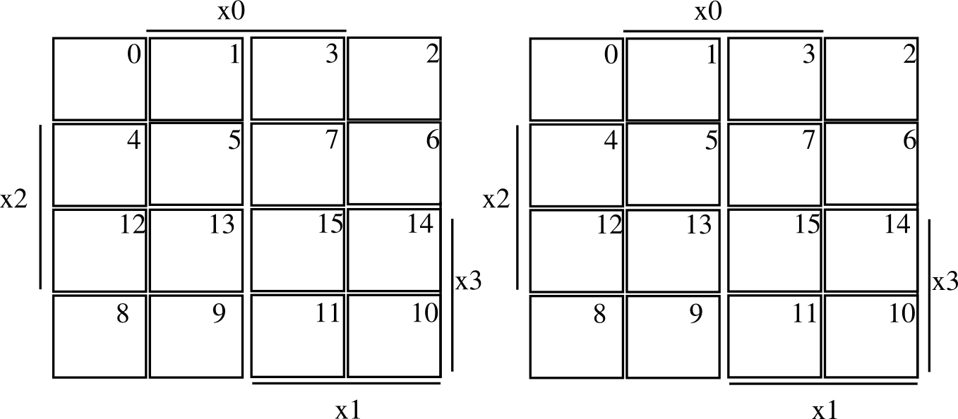

1
1
X
X

X
X
X
X
X
X
X
X

1
1
1
X
X

M = X3 | X1 X2 I = X0 X2

